Word Family Assessment
Name: |  |  |  | Date:
Word Family of the week: |  |  | Rubric Level:
- Show the vocabulary cards and ask, “Can you say these words in English?”
Response:
- What do these words have in common? _______________________________
- Give me a word that rhymes with __________: ______________________
- Can you make up a sentence with one of these words? (Try this twice with words he/she selects)
Response:

Circle One:
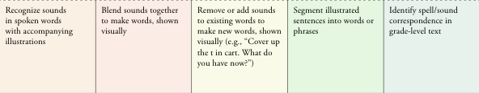
Teacher Observations/ Next Steps:

